

# Using Maven with the IBM App Connect Enterprise Toolkit

Maven :-

* Maven is an open-source build automation and project management tool widely used for Java applications. As a build automation tool.
* it automates the source code compilation and dependency management, assembles binary codes into packages, and executes test scripts.
* Install and configure Maven in your system.
* Create an application, for example, myMavenApp1.
* Create a message flow that includes a Compute node and add the message flow to your application.
* Add a test case to your message flow,Right-click the Compute node and select Create a test case to open the Create test case wizard.

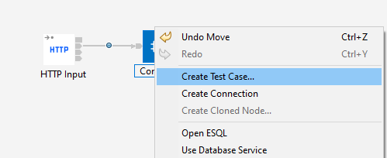

* Optionally, edit any fields and select check boxes as required.
* Click Finish to display the test case in the Java editor of the IBM® App Connect Enterprise Toolkit.

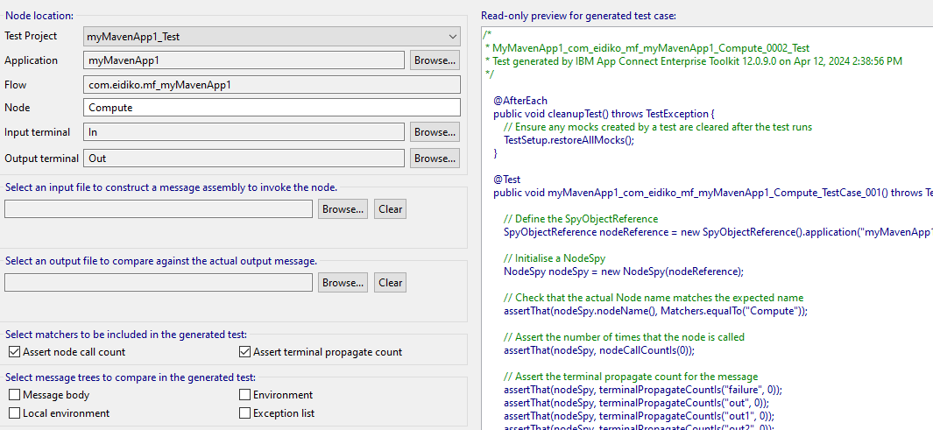

* Right-click the application and select Configure > Convert to Maven Project to open the Maven POM wizard.

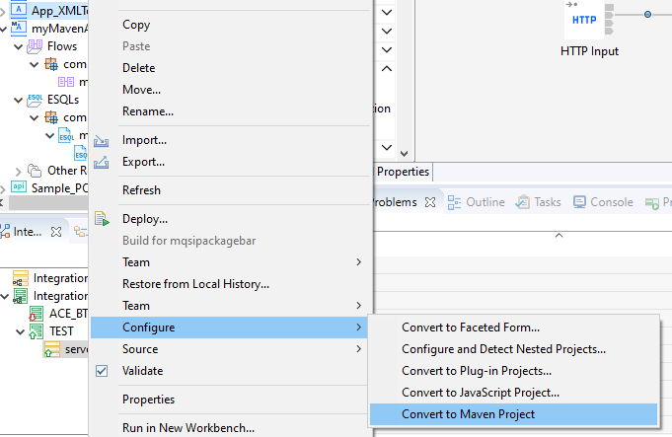

* In the Maven POM wizard, accept the default settings and click Finish.

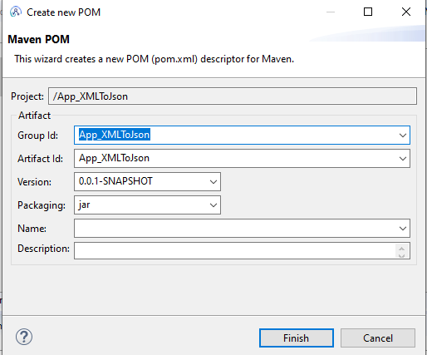

* In the Application Development view of the IBM App Connect Enterprise Toolkit, the letter "M" appears alongside your integration project and alongside the pom.xml file in the Independent Resources section.
* Add a dependencies,In the Other Resources section of the Application Development view, right-click the pom.xml file and select Maven > Add dependency to open the Add dependency wizard.
* Enter a value for Group ID. For example, com.eidiko.code.gson.

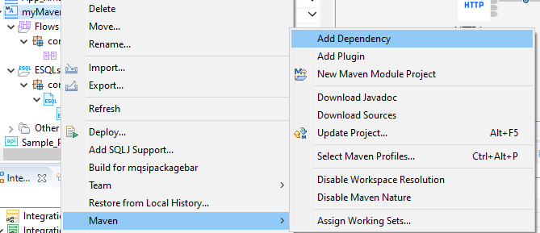

* Enter a value for Artifact ID. For example, gson.
* Enter a value for Version. For example, 1.1.0 and Click OK.
* It will be added in our pom.xml file.

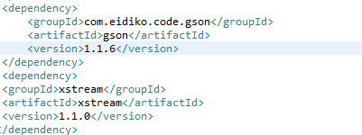

* Open the test case that you created in Step and add a test method to enable the Maven dependencies to be included:

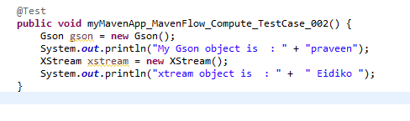

* Errors appear in your integration project after you add the test method to the test case. Resolve the errors by selecting the imports:



* Your integration project is now clean and it contains no errors.

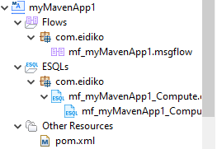

* Right-click your integration project and select Run test project. If you configured Maven correctly, the test passes and information about the gson xstream objects is displayed on the console.

